**Evaluation Development of Strengths (student)** Name: ________________________ Class: __________ Date: ___________

Theme:      ________________________________________________________



I felt : when I: ________________________________________

________________________________________

Happy Afraid Angry Sad Disgusted Surprised

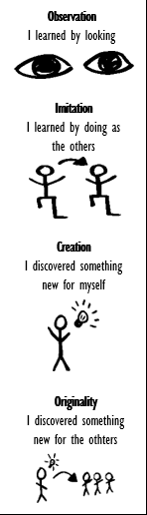What we did: Goals of the lesson: I showed my strengths in: How did I learn?

|  |  |  |  |
| --- | --- | --- | --- |
|  |  | O  O  O  O  Where I can improve:  O  O  O |  |

What did I learn? ________________________________________________________________________________________________

Your challenges: _________________________________________________________________________________________________

Where you can improve: ___________________________________________________________________________________________

What do I need? ­­­­­­­­­­­­­­­­­­­­­­­­_________________________________________________________________________________________________

What is my next step? ____________________________________________________________________________________________